Geography MSL Review (31)
Name: __________________________________________ Date: ________________ Block: ______________
Part 1: Fill in the blank. (17)
- The study of Earth is called GEOGRAPHY.
- Lines of latitude run EAST/WEST and WEST/EAST but measure distance _____________and ______________
- Lines of longitude run NORTH/SOUTH and SOUTH/NORTH but measure distance ___________and __________
- The equator is located at 0 DEGREES LATITUDE_, and the prime meridian is located at 0 DEGREES LONGITUDE.
- M = MOVEMENT R=REGION H=HUMAN E=ENVIRONMENT L=LOCATION P=PLACE

Part 2: Decide whether the statements are examples of ABSOLUTE LOCATION or RELATIVE LOCATION. Write ABSOLUTE or RELATIVE in the space provided (4)
- RELATIVE Ridge Road Middle is located near Highland Creek Elementary School.
- ABSOLUTE Charlotte is located at 36 N, 81 W.
- ABSOLUTE Jim’s House is located at 4908 Ridge Road Ct. Charlotte, NC 28226.
- RELATIVE My Aunt lives 3 blocks away from the Post Office.

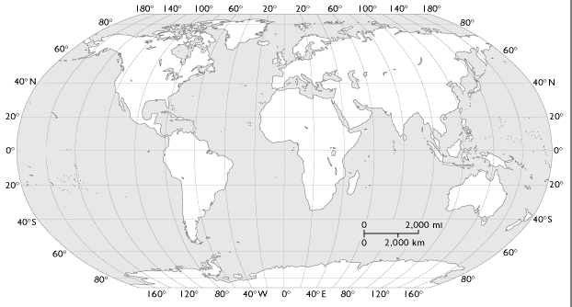
Part 3: Continents, Oceans, and Longitude and Latitude. Use the map to label each continent and ocean. Then, mark the locations for #9-#11 by finding their location with longitude and latitude. (14)
ARCTIC
EUROPE
NORTH AMERICA
ASIA

ATLANTIC
AFRICA

PACIFIC
SOUTH AMERICA
INDIAN
AUSTRALIA
SOUTHERN

- Place a small dot and the #9 on the following coordinate: 20 N, 20 W.
- Place a small dot and the #10 on the following coordinate: 60 S, 120 W.
- Place a small dot and the #11 on the following coordinate: 40 N, 60 E.

Part 4: Definitions and Examples [Pictures or written examples]. *1 Example for each theme* (10)
- Absolute Location-

- Relative Location-

- Movement-

- Place-

- Region-

- Human Environment Interaction-

Part 5: Directions: Write the term next to the correct definition. (10) {Use the Green Textbook to help you}
Word Bank: Tectonic Plates, Hydrologic cycle, Landforms, plateau, Weather, vegetation region, desert, Global Warming Desertification, Climate
- WEATHER is the condition of the Earth’s atmosphere at a given time and place.
- DESERT can be hot or cold and has plants that live in very dry conditions.
- LANDFORMS Features on the Earth’s surface formed by physical forces.
- CLIMATE_is the term for the typical weather conditions of a certain region over a long period of time.
- PLATEAU_is a broad area of land higher than the surrounding land
- HYDROLOGIC CYCLE_the circulation of water between the Earth, the oceans and the atmosphere.
- DESERTIFICATION_the process in which farmland becomes less productive because the land becomes dry.
- VEGETATION REGION_refers to an area that has similar plants.
- GLOBAL WARMING an increase in the average temperature of the Earth's atmosphere.
- TECTONIC PLATES_A large, rigid section of the Earth's crust that is in constant motion.
Part #6 Map Skills: Fill in each definition, explain how it is used, and draw a picture/symbol.
Term: | Definition: | How is it used? | Picture/Symbol:
GLOBE
MAP
CARTOGRAPHER
MAP KEY
PHYSICAL MAP
POLITICAL MAP

Part 6: Use your notes to fill in the chart. Correctly identify each physical feature that is important to the River Valley Civilizations and Early Civilizations we have studied. (36)

 | Egypt | Mesopotamia | China | India | Greece | Rome
Rivers | NILE | TIGRIS  EUPHRATES | YANGTZE  YELLOW or HUANG | GANGES  INDUS |  | TIBER  PO
Mountains |  | ZAGROS | HIMALAYAS  OR MT. EVEREST | HIMALAYAS  OR MT. EVEREST | OLYMPUS | APENNINE  ALPS
Seas | RED SEA  MEDITERRANEAN | BLACK  CASPIAN  RED  MEDITERRANEAN | SOUTH CHINA  EAST CHINA  YELLOW | ARABIAN | IONIAN  AEGEAN  SEA OF CRETE | ADRIATIC  TYRRHENIAN  IONIAN  MEDITERRANEAN
Deserts | LIBYAN  NUBIAN |  | GOBI | THAR

Name: __________________________________ Date: _____________________ Block: ___________________
Government and Economy Formative Review Packet (4)
Part I: Governments (Chapter 3 Section 4: Pages 79-81)
1. What is a government? (Use page 78 of your green book to write the definition.)
an organization set up to make and enforce rules for a society/groups of people
Government Chart: We have learned about various types of governments that have been used around the world. Using your notes, please list three key facts or places that the style of government was used.
Democracy | Oligarchy | Dynasty | Republic | Dictatorship

2. What type of government does the United States have? _______democracy_______________________________
3. What type of government did Greece have? ___Monarchy, Oligarchy, Tyranny, Democracy (any 1 or all)
4. Name one country where you would find an Oligarchy: ______ ________________________
5. Name one country where you would find a Republic: ________ ____________
6. How do the philosophies (Daoism, Confucianism, Legalism) of China influence the style of government? ____________________________________________________________________________________________________________________________________________________________________________________________________
7. What is the difference between a representative democracy (United States) and a direct democracy (Greece)?
In a representative democracy, people vote on one person to vote on decisions on their behalf. In a direct democracy, each citizen has a say in the votes.

Part II: Economies (Chapter 3 Section 3, pages 75-77) (5)
1. What is an economy? (Use page 75 of your book to define.) production and exchange of goods and services among a group of people
Using your notes and book, please give the definition and list 2 key facts about each economic factor listed below.
Renewable Resource | Nonrenewable Resource | Import | Export
Definition:  Can be replaced through natural processes; those that nature can replace, like trees or plants | Definition:  Can’t be replaced once they have been removed from the ground; can’t be easily replaced so when they are used up there aren’t additional resources, like coal and oil | Definition:  A product or resource that comes into a country | Definition:  A product or resource sold to another country
Fact #1: | Fact #1: | Fact #1: | Fact #1:
Fact #2: | Fact #2: | Fact #2: | Fact #2:
2. What is the difference between an export and an import? __________________________________________________________________________________________________
3. What is the importance of a civilization trading? __________________________________________________________________________________________________
4. What is the importance of a strong economy? Does a strong economy mean a better quality of life? ____________________________________________________________________________________________________________________________________________________________________________________________________
5. How did domestication of plants and animals impact economies of future civilizations? ____________________________________________________________________________________________________________________________________________________________________________________________________
6. What role did agriculture play in the rise of civilizations?
____________________________________________________________________________________________________________________________________________________________________________________________________
7. Look at the sequence of events to help you fill in the missing link. Each factor had to happen in order to lead to the final piece.
Hunter-gatherers : Nomads : Water Source : Agriculture : Domestication : _______________________________
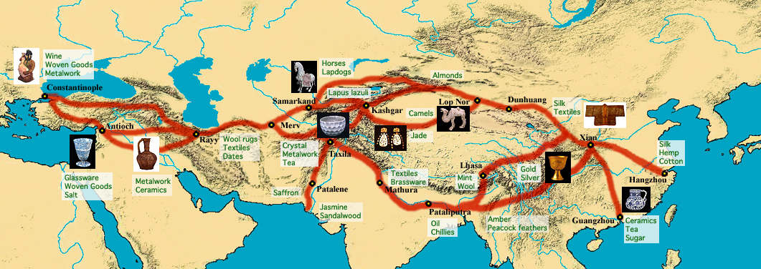
(3)

What is the Silk Road? Create a chart of products that came from Asia to Europe and of products that went from Europe to Asia. A series of trade routes/networks from Asia (China) to Europe (Greece)
Goods Made in Asia | Goods Made in Europe

8. What product allowed China to stay #1 economically? What was there plan to keep others from making the product?
Silk; to form a monopoly on silk where China had complete control on the price and availability of silk by not telling other civilizations how it was made so they were the only ones who could produce it
9. How do natural resources influence trade? Which civilization is “richest” (has a lot of natural resources) in your opinion? ______________________________________________________________________________________________________________________________________________________________________________________________________________________________________________________________________________________________________

MSL REVIEW STUDY GUIDE UNITS 6-7 (10)
Studied with: ________________
Unit 6 Early Humans:
    - What is the job of an archeologist?_______________________________________________________________________________________________.
    - Another name for the Neolithic Revolution is the AGRICULTURAL REVOLUTION or NEW STONE AGE
    - Nomads are people who? ____________________________________________________________________
    - Why were early people nomads? ______________________________________________________________________________________________
    - The Neolithic Revolution refers to a time when early humans ________________________________________________________________
    - What is the work of an anthropologist? ________________________________________________________________________
    - Why did early humans move out of Africa? CLIMATE CHANGE or GRASSLANDS TURNED TO DESERTS or DECREASE IN FOOD
    - What do you know about the life of early humans? _______________________________________________________________________________
    - How did the early humans use the land bridge? ___________________________________________________________________________________
    - In the Paleolithic Era, what was the role of a hunter? ___________________________________________________________________________
    - The period of time in which no written records were kept is called PREHISTORY
    - An ancestor of humans that developed in Africa are called NEANDERTHALS or HOMINIDS
14. B Australopithecus  15. _E_ Homo Sapien Sapien  16. F_ Homo Erectus  17. D_ Homo Habilis  18. _C_ Homo Sapiens  19. _A_ Neanderthal | - Were killed off by Homo Sapiens Sapiens  - Also known as the “Southern Ape.”  - Also known as the “Wise Man.”  - Known as the “Handy Man.”  - Known as the Modern Human Being. Replaced Neanderthals.  - Name means “upright man”
    - Explain what happened to the Neanderthals. _______________________________________________________________

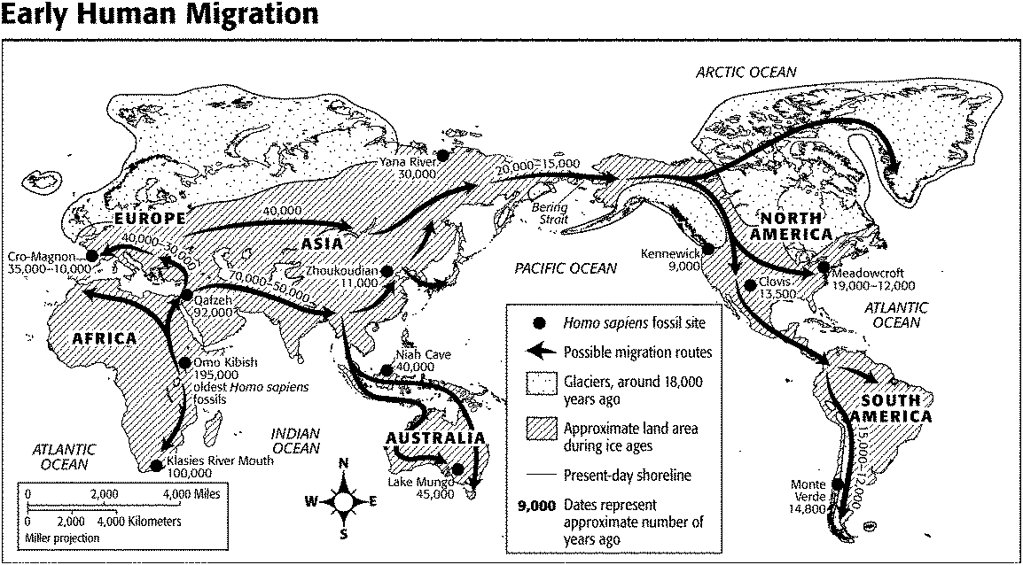
Map Skills:

Unit 7- Early Civilizations: (6)
- What geographic features attracted people to settle in Mesopotamia?
  - _______________________________________
  - _______________________________________
  - _______________________________________
- What is a ziggurat and what it was used for? ______________________________________________________
- What type of community was Ancient Sumer known as? ____________________________________________
- How were the Tigris and Euphrates Rivers used in early civilizations? [Must list four different ways]
  - _______________________________________
  - _______________________________________
  - _______________________________________
  - _______________________________________

- What does Mesopotamia translate to? BETWEEN TWO/THE RIVERS
- Who was the first epic in Ancient Sumer called? GILGAMESH
- What did cuneiform allow people to do that they were unable do in the prehistoric era? WRITE OR KEEP RECORDS OR KEEP LAWS
- How does language unite people and keep order? __________________________________________________
- List the 2 BIG inventions of Ancient Sumer. SEEDER PLOW, DAMS, CUNEIFORM, WHEEL (any TWO)
- Where were Babylonia, Assyria, and Sumer located inside of Mesopotamia?
Assyria: Babylonia: Sumer:
10. Describe Hammurabi’s code: ______________________________________________________________________
11. How did laws effect Babylonia’s culture? ____________________________________________________________
12. Which empire was able to defeat the powerful Babylonia? ASSYRIAN
13. What purpose did canals serve in Mesopotamia? ____________________________________________________
14. Compare Mesopotamia to another river civilization of your choice. Fill in the chart
Place: | Mesopotamia
River(s):
Other Geographical Features
Culture [Language, Religions, etc]

Unit 8 Egypt Midterm Review (13) Name: ___________________________ Date: ____________ Block:

1. What is the lowest class of ancient Egypt? __________________________________________________________
2. Egyptians invented a form of picture writing called hieroglyphics
3. What surrounded the Nile River that offered protection from invasion? deserts
4. The rulers of ancient Egypt were known as pharaohs
5. The largest social class in Ancient Egypt was the slaves
6. The body of a dead person that is embalmed, dried, and wrapped in linen bandages is called a(n)mummy
7. Which region in Egypt was known for its fertile land?Fertile Crescent
8. The silt at the Nile’s mouth forms a triangle shaped called a(n) delta
9. What was known as the “highway” of Egypt? the Nile River
10. The Pharaohs were buried in pyramids located in ____________________________________________________
11. Ancient Egyptians practiced what religion? polytheism
12. What did the Egyptians do with the surplus of goods? ________________________________________________
13. One scientific achievement of the Ancient Egyptians that is still practiced today is ________________________
14. What good did Egyptians not have access to? _______________________________________________________
15. The organs of the mummified bodies were stored in what? _____________________________________________
18. What did the Egyptians think would happen after death? _______________________________________________
19. The Nile is hard to navigate in the southern end because of six waterfalls called cateracts
20. In which month did the Nile River flood? June/ summer months
22. Which social group preformed the ceremonies on the pharaohs after they died? ___________________________
23. Who was the most important person to the Ancient Egyptians? _________________________________________
24. What organ was removed initially and then placed back into the body for burial? __________________________
25. What were the Egyptians born into? ________________________________
26. Which archeological find helped people to understand hieroglyphics? ___________________________________
28. A series of rulers from one family is called a dynasty
29. The Nile River flows in which direction? north
Pharaoh
Government Officials
Soldiers
Scribes
Merchants
Slaves and Servants
Farmers
Artisans
Unit 9: Religion Midterm Review (15)
Name:__________________________________________Date:__________________Period:______________
Christianity | Islam | Judaism | Hinduism | Buddhism
Type: monotheism | Type: monotheism | Type: monotheism | Type: polytheism | Type: polytheism
Founder: Jesus | Spread by: Muhammed | Founder: Abraham | Founder: none | Founder: Buddha/Siddhartha
Name of Follower: | Name of Follower: | Name of Follower: | Name of Follower: | Name of Follower:
Holy Book: | Holy Book: | Holy Book: | Holy Book: | Holy Book:
Name of God:  God | Name of God:  Allah | Name of God:  God | Name of God:  Brahman | Name of God:  no god

Sample Midterm Questions:
- What is a common religious characteristic of Judaism, Christianity, and Islam?
- The religion of the Aryans, who invaded India around 1500 BCE, evolved into which of these world religions? Hinduism
- Which major world religion is most directly influenced by Judaism? Christianity
- What are the “5 Pillars of Islam”? faith, prayer, charity, fasting, pilgrammage
- About 80 percent of the people of India practice which religion? Hindusim
- What is the “8 Fold Path”? the way to end suffering AND/OR observing right: opinions, desires, speech, action, jobs, effort, concentration, meditation
- After Ashoka died, what contributed to Buddhism’s return to its status as a minor religion in India?
- A sharing and spreading of religion, art, and ideas between civilizations is known as what? cultural diffusion
- What is the difference between monotheistic religions and polytheistic religions? monotheistic is worship of one god/deity and polytheistic is worship of many gods/deities
Unit 10 INDIA Midterm Review (16) Name: ___________________________ Date: ____________ Block:

1. What is the lowest class of ancient India? __________________________________________________________
2. What written language did the Aryans use to write the Vedas? sanskrit
3. What natural barrier is in the north of India? Himalays
4. What did it protect Ancient India from? Mongolians/other invaders/attackers
5. The highest social class in Ancient India were the Brahmins
6. Flooding and the wet season from monsoons provided India with fertile soil/silt/fertile land (NOT just water)
7. What 2 major rivers did the population settle near Ganges and Indus
8. Who were the invaders who brought the basis for the caste system? Aryans
9. What were the 3 P’s of the Golden Age? ______________________________________________________________
10. What major role did the caste system play in Indian society? ___________________________________________
11. Ancient Indians practiced what 2 religions? Buddhism and Hinduism
12. What class included the rulers and warriors in the caste system? Kshatriyas
13. One major achievement of the Ancient Indians that is still practiced today is ______________________________
14. Great works of literature, music, and art were part of what era? _________________________________________
15. Who was the founder of Buddhism? ________________________________________________________________
16. Is there a founder of Hinduism? Explain. ____________________________________________________________
17. Which social group contained impure workers who were discriminated against? pariah/untouchables/outcasts
18. What social system were Indians born into? ________________________________________________________
19. A series of rulers from one family is called __________________________________________________________
20. The rules of the caste system covered what aspects of life? ____________________________________________
21. Name one body of water that touches India? _________________________________________________________
22. India is a subcontinent located on which continent? Asia
23. This emperor traded bloodshed for the peacefulness of Buddhism Ashoka
24. What dynasty controlled India during the Golden Age? __________________________________
25. Who established the Mauryan Empire? What was his connection to Asoka? Chandragupta/ Maurya; his grandfather
26. How did Asoka spread his new belief system? _______________________________________________________
27. What animal did Asoka use during his conquest? How?_______________________________________________
28. Name the 4 major geographic features of that made people want to settle in Northern India?
_______________________ _____________________________ _______________________ ____________________
29. Why did Asoka convert to Buddhism? _____________________________________________________________
30. What is called when one culture borrows an idea from another? Give an example from India._____________________________________________________________________________________________
31. Place the class in the correct position on the caste system
- Brahmin (Priests & Scholars)
2. Kshatriyas (Warriors & Rulers
3. Vaisyas (merchants & farmers)
5. Pariah Untouchables (Outcasts)
4. Sudras (peasants & servants)
Count up the number of times you had to correct an answer. Subtract that number from 180, and write that answer at the bottom of page 1 (Historical Themes) next to your name; circle the number.

For example: The paper I have has 14 colored marks where I had to correct 13 different answers. 180-14=166. I write 166 at the bottom of page 1 and circle it.
166

Make it out of 250 (60 points of completion) because there’s 36 Historical Themes Examples. You can’t subtract more than 40 points for completion. Take completion points (start from 60), add to circled number, divide by 200, that’s their score; count 2X Formal Grade out of 100.

