Philosophers & Leader of Ancient Greece Online Reading Research

SOURCE 1 → READING Directions:
- Read the paragraph below
- Highlight THREE important details FOR EACH LEADER as you read.
- After you read, fill in your EVIDENCE on your graphic organizer about Socrates

#1  Socrates | 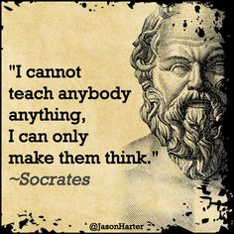
Socrates was a philosopher who taught by asking questions. When teachers ask questions that encourage students to draw conclusions, they are using the "Socratic method" of teaching. Socrates asked many questions, but he gave few answers. Socrates was a well-known teacher in Athens. He drifted around the city with his students, engaging many people in arguments. What we know about Socrates comes from what others wrote about him. Socrates did not write any books since he believed it was better to debate than write.
Socrates regarded the tales of the gods as just make-believe. This upset the leaders of Athens and they threatened to bring him to trial for neglecting the gods and for corrupting the children of Athens by encouraging them to consider new ideas. The leaders expected the seventy year old Socrates to leave Athens before his arrest, but he remained in Athens, stood trial, and was found guilty. A friend tried to plan an escape from prison, but Socrates refused to participate. He believed that he must obey the law, even if he disagreed with it. His last day was spent with friends. At the end of the day, Socrates calmly drank from a cup of poison hemlock, the customary practice of execution at that time.

SOURCE 2 → Video Directions:
- Watch the video: Click Here--> IT IS OKAY IF THE VIDEO STOPS EARLY. DO NOT CREATE AN ACCOUNT.
- After you listen, fill in your EVIDENCE on your graphic organizer about Socrates.

SOURCE 1 → READING Directions:
- Read the paragraph below
- Highlight THREE important details FOR EACH LEADER as you read.
- After you read, fill in your EVIDENCE on your graphic organizer about Plato
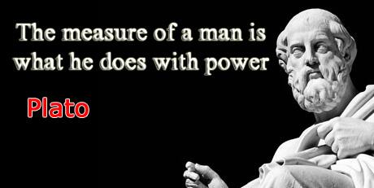
#2
Plato

Most of what we know about Socrates comes from Plato, his most famous student. When his teacher was executed, Plato left Greece for more than a decade. He returned to start the Academy, a school that would operate for more than 900 years. Under Plato, the Academy offered instruction in mathematics, science, and philosophy. As the Academy developed it established courses and a curriculum. The Academy was not open to all citizens, and it aimed to prepare its students for roles as statesmen, or political leaders. Some historians consider the Academy one of the first models for modern universities.
Plato described his idea of the best society in his most famous book, the Republic. Plato did not believe in democracy. He argued in favor of an “aristocracy of merit,” where there would be rule by the best and the wisest people. Plato believed a small group of people intelligent and educated men and women should govern everyone. One of the most famous of Plato’s later dialogues is The Republic, which discusses ideas of justice and different forms of government. In it, Plato describes an ideal state. The state has three social classes: the philosopher kings, the guardians, and the producers—ordinary citizens, such as farmers, merchants, and craftspeople. Each class has its own role: The king rules the state, the guardians defend the state and keep order, and the ordinary citizens produce what is needed by people living in the state. Plato believed a healthy state is one in which each class performs its own responsibilities properly.

SOURCE 2 → Video Directions:
- Watch the video: Click Here!
- After you listen, fill in your EVIDENCE on your graphic organizer about Socrates.

SOURCE 1 → READING Directions:
- Read the paragraph below
- Highlight THREE important details FOR EACH LEADER as you read.
- After you read, fill in your EVIDENCE on your graphic organizer about Aristotle

#3  Aristotle | 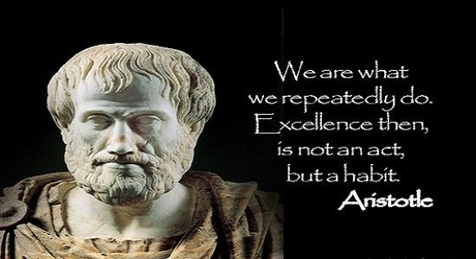
Aristotle was the greatest scientist of the ancient world. Aristotle believed in using science and reason, rather than the anger or pleasure of gods, to explain natural events. Aristotle moved to Athens and studied at Plato's Academy. He remained at the school for more than twenty years until shortly after Plato died. Aristotle then returned to his home in Macedonia, where King Philip hired him to prepare his thirteen-year-old son, Alexander, for his future role as a military leader. His student would one day be known as known as Alexander the Great, one of the greatest military conquerors of all time.
Once Alexander became King of Macedonia, Aristotle returned to Athens and opened a school he called the Lyceum. For the next twelve years, Aristotle organized his school as a center of research on astronomy, zoology, geography, geology, physics, anatomy, and many other fields. Aristotle wrote 170 books, 47 of which still exist more than two thousand years later. His ideas formed the basis of modern science.

SOURCE 2 → Video Directions:
- Watch the video Click Here --> IT IS OKAY IS IF THE VIDEO CUTS OFF. DO NOT CREATE AN ACCOUNT
- After you listen, fill in your EVIDENCE on your graphic organizer about Socrates.

SOURCE 1 → READING Directions:
- Read the paragraph below
- Highlight THREE important details FOR EACH LEADER as you read.
- After you read, fill in your EVIDENCE on your graphic organizer about Socrates

#4  Alexander  The Great | 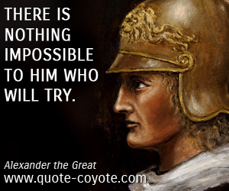
Alexander the Great became King of Macedonia at the age of 20 when his father was assassinated in 336 AD. The Greeks believed they could free themselves of Macedonia rule, since the new king was a "mere boy." Alexander proved them wrong by capturing the city of Thebes. He destroyed the entire city as a warning to the others. Alexander then conquered Persia, the longtime enemy of Greece, and the mightiest empire in the world.
Alexander was a military genius, possibly the greatest warrior of all time. His troops were better trained and organized than the Persian army. His soldiers also admired Alexander because of his personal courage. Alexander led his soldiers in battle instead of remaining behind the lines. The troops saw that Alexander was sharing their danger, and was not asking them to take any risks he would not take himself. Once he conquered the Persians, Alexander quickly assembled a huge empire. In 332 BC, he moved south to Egypt, where he rested his troops. The Egyptians welcomed Alexander as a hero because he freed them from harsh Persian rule. They crowned him Pharaoh and declared him a god.
Alexander eventually created an empire that reached India. Aristotle taught him that the Greeks were the most advanced people in the world, and that all other cultures were barbarians. Once he defeated the Persians, he came to see them very differently. He saw that many Persians were intelligent people and were worthy of his respect. Alexander accepted many Persians into his army and married the daughter of a Persian king.
In 323 BC, when Alexander was only thirty-three years old, he fell ill from a fever and died a week later. Alexander had created a huge empire in less than thirteen years, but it quickly crumbled. Alexander changed the world, but not through his accomplishments on the battlefield. Alexander carried the ideas of the Greeks and their love of learning throughout his empire. He founded the great city of Alexandria, which became a center of learning and culture in Egypt. A library in Alexandria housed the accumulated knowledge of the Greeks.

SOURCE 2 → Video Directions:
- Watch the video: Click Here!
- After you listen, fill in your EVIDENCE on your graphic organizer about Alexander the Great

