Analyzing Hammurabi’s Laws (60 Point Informal)
DIRECTIONS
- Copy the law in bold black letters. Use color for everything else. (5 points)
- Explain what you think the law means in your own words. (in color) (10)
- Illustrate the law (yes, it needs to be colored). (10)
- Explain how this law relates to current laws we have in the U.S. Give at least 1 similarity and 1 difference. (in color) (10)
- Is your law/punishment affected by the social structure/classes of Mesopotamia? Why or why not? (in color) (10)
- Be neat and creative. (15)
EXAMPLE
- If fire break out in a house, and someone who comes to put it out cast his eye upon the property of the owner of the house, and take the property of the master of the house, he shall be thrown into that self-same fire.
- I believe this law means that if there is a fire and someone goes in to help with the fire but they instead steal property, the thief will be thrown into the fire as punishment.
=
- 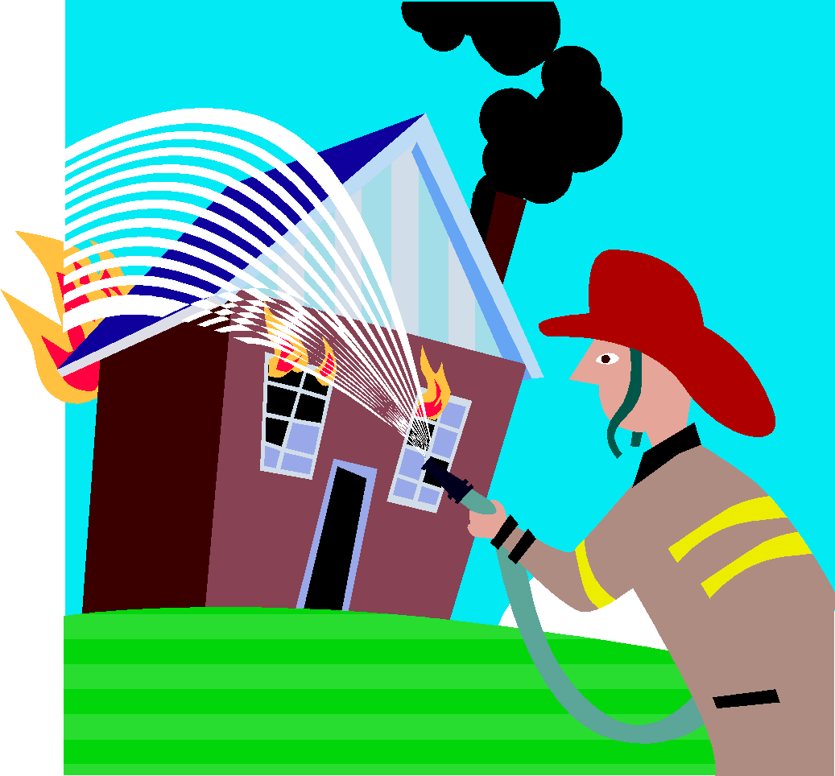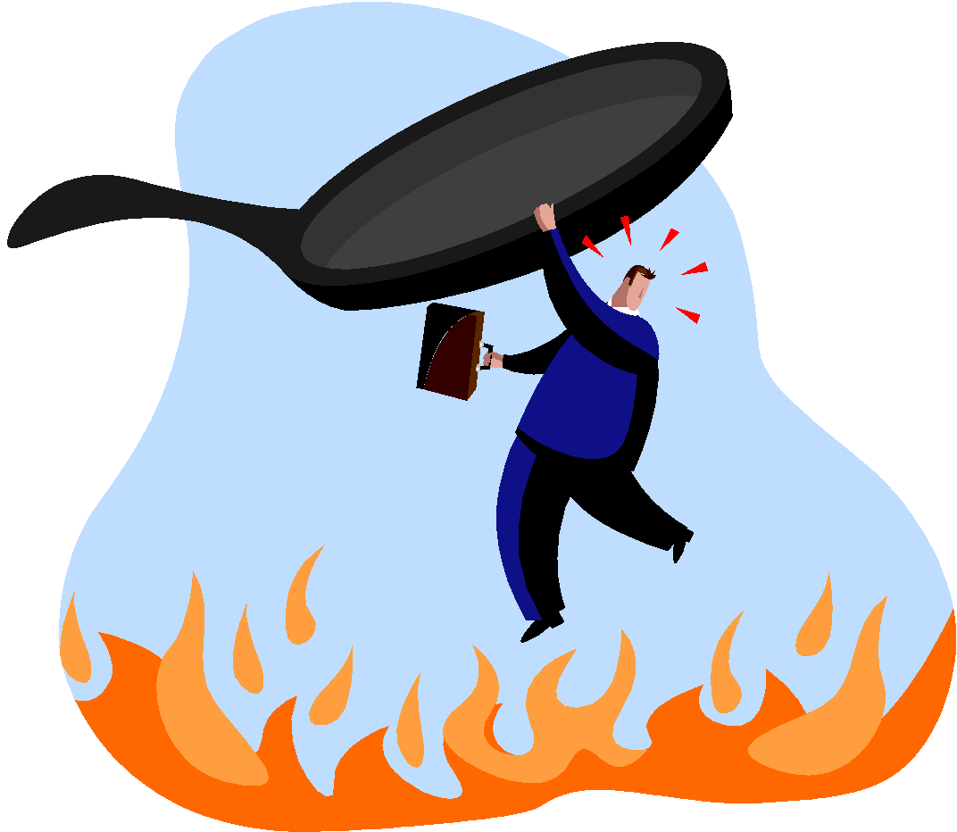
- Under our laws criminals are punished for stealing just like in this law. However, they are not given physical harm but usually time in jail or having to pay a fine.
- Punishment is not affected by your social class because it doesn’t matter where you rank if you steal. Your punishment will be the same as everyone else who steals.

