NAME ______________________________________________________ BLOCK_________________

**The Black Death Webquest**

**THE BASICS**   
<https://web.cn.edu/kwheeler/black_plague.html>

1. List four (4) other names for the Black Death.

2. What insect transmitted the disease? How did humans pass the disease to each other?

3. How/why did the Black Death improve life for serfs and peasants? How was trade affected (give specific numbers)?

**THE SPREAD**  
<http://wadsworth.cengage.com/history_d/templates/student_resources/0534600069_spielvogel/InteractiveMaps/swfs/map11_1.html>

Click through the timeline of the map, noticing the color changes and the key; read the information below the map as you click. Answer the questions.

1. Through which form of transportation did the plague arrive in Europe?

2. In what month and year did the plague first arrive in Europe?

3. In what month and year did the Plague arrive in Rome? in the Alps? the area around the Baltic Sea?

4. What group of people was blamed for the Plague?

5. List the two (2) islands that were unaffected by the Plague. What is the reason these areas probably were not affected?

6. About how many people total died from the Plague? Give a number, not a fraction or percentage.

**SYMPTOMS**  
<https://www.verywell.com/pictures-of-bubonic-plague-4020318>

In/around the body below, draw and label six (6) symptoms of the Black Death. Use color!

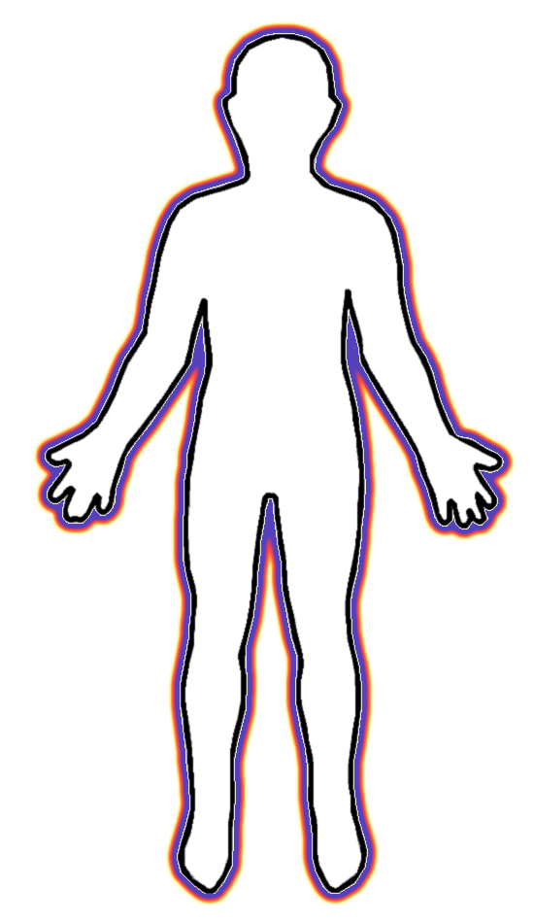

<http://medievaleurope.mrdonn.org/plague.html>  
For each line from “Ring Around the Rosie”, write what it means about the Black Death.

|  |  |
| --- | --- |
| Ring around the Rosie |  |
| Pocket full of Posey |  |
| Ashes, Ashes |  |
| We all fall down! |  |

Do you think differently about this nursery rhyme now? Why or why not?

**CURES**  
<http://listverse.com/2013/01/21/10-crazy-cures-for-the-black-death/>

In each of the boxes, illustrate one (1) cure for Black Death. Write a one (1) sentence caption for what is going on in your sketch. You will have three (3) different pictures with three (3) captions. Use some color. Then, answer the questions below.

1. Which cure do you think would have been most effective? Why? (You can pick from all 10; doesn’t have to be 1 you drew.)

2. Which cure do you think would have been least effective? Why? (You can pick from all 10; doesn’t have to be 1 you drew.)

3. Which cure do you think sounds the most bizarre? What is so weird about it? (You can pick from all 10; doesn’t have to be 1 you drew.)

_____________________________  
  
_____________________________  
  
_____________________________

_____________________________  
  
_____________________________  
  
_____________________________

_____________________________  
  
_____________________________  
  
_____________________________